"Identifying Key Predictors of Customer Churn Using Logistic Regression"
Jen Sengbe
Predictive Modeling
March 15, 2025

RESEARCH QUESTION
In today’s competitive telecommunications industry, retaining customers is a top priority, as losing them can significantly impact a company’s profitability and growth. To address this challenge, the organization is conducting an analysis to answer the question: “What customer characteristics and service-related factors are significant predictors of customer churn, and can we accurately predict churn using logistic regression?” By examining patterns in customer demographics, service usage, and account features, this study aims to identify which factors most strongly influence whether a customer stays or leaves. Logistic regression is the chosen method due to its effectiveness in modeling binary outcomes, such as the churn variable (Yes or No). The findings will support the development of proactive strategies to reduce churn and strengthen customer loyalty.
GOALS
By exploring the relationships between various customer attributes and their decision to discontinue service, this analysis seeks to determine whether certain demographic, behavioral, or account-based factors have a measurable influence on customer churn. Identifying these patterns can help guide interventions aimed at improving retention, whether through targeted communication, service modifications, or loyalty initiatives. Unlike industries where companies can selectively attract or retain customers, telecommunications providers often operate in highly saturated markets where customers have many competing options and may leave with little warning. As a result, companies must develop strategies to meet customers where they are—understanding their needs, frustrations, and usage habits in real time.
Gaining insight into the key drivers of churn, even if not strictly causal, equips the organization with the tools to intervene meaningfully. These interventions can help maintain customer relationships, extend customer lifecycles, and ultimately reduce churn-related losses. In this way, logistic regression becomes not just a modeling technique but a decision-support mechanism that aligns data-driven insights with practical business action—strengthening loyalty, enhancing satisfaction, and ensuring long-term organizational sustainability.
SUMMARY OF ASSUMPTIONS
Logistic regression relies on several key assumptions to ensure the accuracy and validity of its predictions. First, the dependent variable must be binary, meaning it can only have two possible outcomes, such as "Yes" or "No"—as is the case with customer churn in this analysis ("Logistic Regression in Clinical Studies" 68). Second, the model assumes there is no significant multicollinearity among the explanatory variables ("Logistic Regression in Clinical Studies" 70). When independent variables are highly correlated with each other, it becomes difficult to determine their individual impact on the response variable, which can distort the results. Third, the observations must be independent; each row in the dataset should represent a unique observation that does not influence or depend on another ("Logistic Regression in Clinical Studies" 74). A fourth assumption is the absence of extreme outliers, as these can significantly skew the model and reduce its ability to make accurate predictions ("Logistic Regression in Clinical Studies" 78). Fifth, there should be a linear relationship between the independent variables and the logit (log-odds) of the dependent variable—this is different from linear regression, which requires a linear relationship between the independent and dependent variables themselves("Logistic Regression in Clinical Studies" 79). Lastly, logistic regression requires a sufficiently large sample size to ensure the stability and generalizability of the model. Without enough data, the model may draw conclusions based on anomalies rather than patterns that are likely to hold true in a larger population.
TOOL BENEFITS
Python is a powerful programming language for conducting logistic regression and other forms of data analysis due to its versatility, readability, and the broad range of libraries it offers. One of the key benefits of using Python is its extensive ecosystem of data science libraries such as pandas, numpy, matplotlib, seaborn, and scikit-learn (Joshi and Tiwari 85). These tools streamline each phase of the analysis—from cleaning and exploring the data to building and evaluating models. Specifically, scikit-learn provides intuitive functions for fitting logistic regression models, checking model accuracy, and generating performance metrics like confusion matrices and ROC curves (Joshi and Tiwari 85).
Another benefit of Python is its ability to integrate code, visualizations, and narratives into a single environment such as Jupyter Notebook. This not only enhances the reproducibility of the analysis but also makes it easier to share insights with stakeholders in a clear and interactive way. With built-in support for version control and automation, Python empowers analysts to efficiently iterate through models, compare results, and make data-driven decisions with confidence.
APPROPRIATE TECHNIQUE
Logistic regression is an appropriate analytical technique for this study because the primary objective is to predict a binary outcome—whether a customer will churn ("Yes") or not ("No"). The Churn variable in the dataset serves as the dependent variable and meets the requirement for logistic regression, which is specifically designed to model dichotomous outcomes. This method estimates the probability that a customer will churn based on a set of explanatory variables such as tenure, contract type, monthly charges, and service features.
In addition to the binary nature of the outcome, logistic regression is well-suited for understanding the relationship between multiple independent variables and the likelihood of a specific event occurring. It not only allows for prediction, but also provides interpretable coefficients that show the direction and strength of influence each variable has on the odds of churn. This makes logistic regression both a practical and strategic tool in the context of customer retention, enabling the organization to identify which factors are most predictive of churn and to take preemptive action based on data-driven insights.
DATA CLEANING GOALS
The primary goal of the data cleaning process is to ensure that the dataset is ready for logistic regression modeling by resolving issues that could compromise the accuracy or interpretability of the model. Using Python, the cleaning process began by importing the dataset into a Pandas DataFrame and performing an initial inspection using .head() and .info() to understand the structure of the data. Columns that did not contribute predictive value, such as 'CustomerID', were removed using the .drop() function. The dataset was then examined for missing values using .isnull().sum() to ensure data completeness (Altman and Bland 903). Since logistic regression in Python's scikit-learn requires numerical inputs, all categorical variables were converted into binary dummy variables using pd.get_dummies() with drop_first=True to avoid the dummy variable trap (Altman and Bland 903). To address potential multicollinearity between explanatory variables, a correlation matrix was generated using df.corr() and visualized with seaborn.heatmap(). Finally, extreme outliers were detected using the Z-score method from scipy.stats.zscore, and rows with absolute Z-scores greater than 3 across numeric columns were filtered out (Altman and Bland 903). These cleaning steps produced a refined dataset suitable for building a valid and interpretable logistic regression model.
Step 1: Load relevant libraries
import pandas as pd
import numpy as np
import seaborn as sns
import matplotlib.pyplot as plt
Step 2: Load dataset
import os
os.getcwd()
df = pd.read_csv('/Users/jensengbe/Desktop/School/Predictive Modeling/Linear Regression Modeling/Data Files/d9rkejv84kd9rk30fi2l/churn_clean.csv')
Step 3: Preview dataset
df.head(10)
Step 4: Print list of columns
print(df.columns.tolist())
Step 5: Drop columns not useful for modeling
df.drop(columns=['Customer_id'], inplace=True)
Step 6: Check for missing values
missing = df.isnull().sum()
print("Missing values per column:\n", missing[missing > 0])
Step 7: Handle missing values
df['InternetService'] = df['InternetService'].fillna(df['InternetService'].mode()[0])
C2. SUMMARY STATISTICS
The dataset was first loaded into a Pandas DataFrame, and columns irrelevant to prediction—like CustomerID—were removed. The .isnull() method was used to check for missing values, and numeric-like object columns such as 'TotalCharges' were explicitly converted to float using pd.to_numeric() to ensure consistency. All object-type columns were then identified with select_dtypes(include=['object']) and transformed into numerical format using pd.get_dummies() with drop_first=True to prevent multicollinearity due to redundant dummy variables. A correlation heatmap was created using seaborn.heatmap() to visually inspect relationships between variables. Finally, Z-scores were calculated on numeric columns to remove extreme outliers, keeping only rows where all Z-scores were less than 3. These steps collectively produced a cleaned dataset that is now well-prepared for logistic regression modeling.
The dependent variable (response variable) in this logistic regression model is Churn, which indicates whether or not a customer has left the company. The explanatory (independent) variables I will analyze are selected based on their relevance to customer behavior and service usage. These include Tenure, MonthlyCharges, Contract, TechSupport, and InternetService. Below are the summary statistics and contextual analysis for each.
Churn (Dependent Variable)
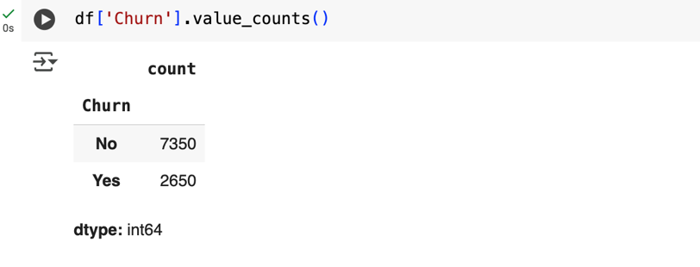
Tenure (Independent Variable)
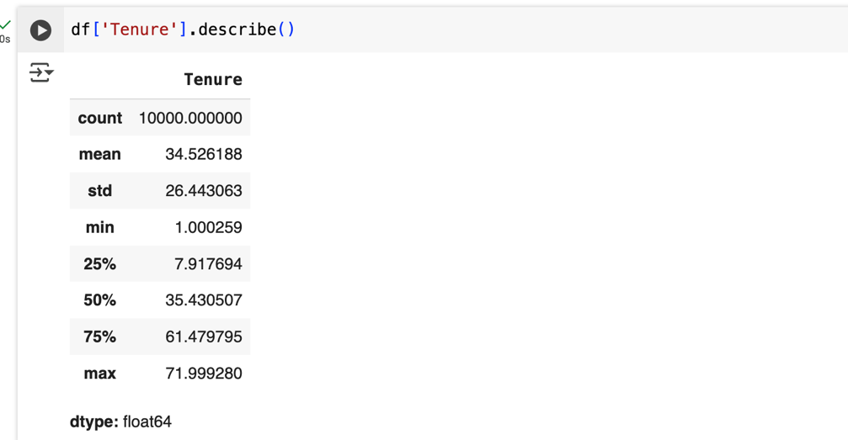
MonthlyCharge (Independent Variable)
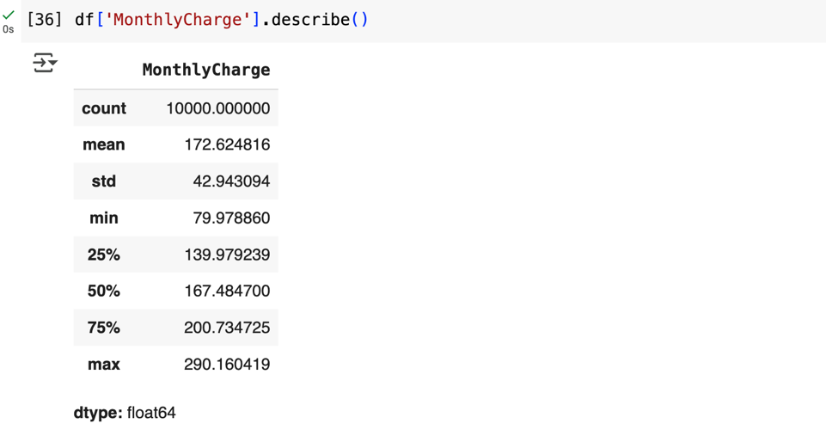
Contract (Independent Variable)
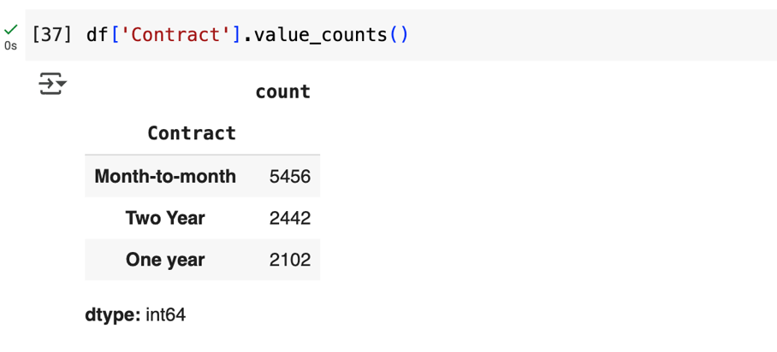
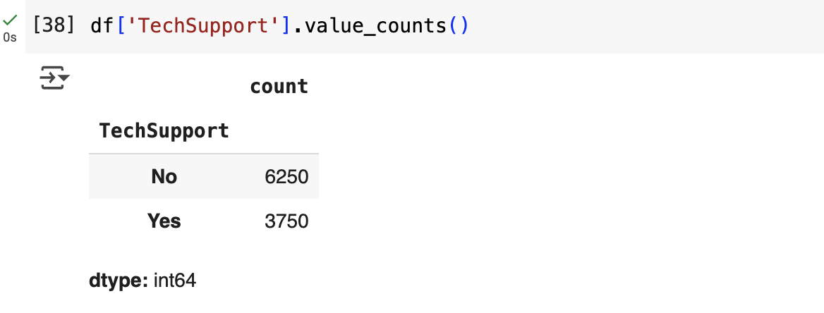
TechSupport (Independent Variable)

InternetService (Independent Variable)
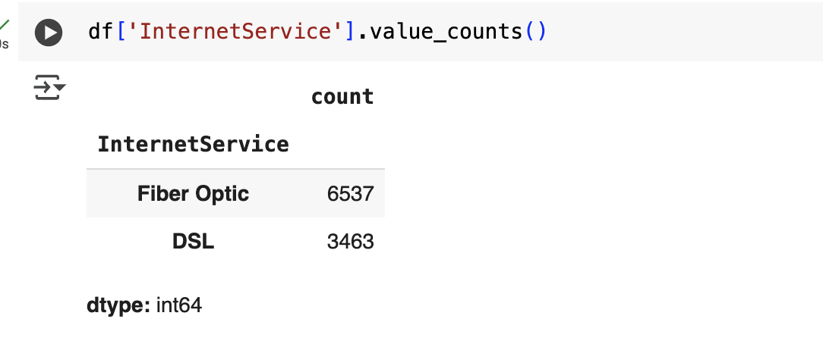
Visualizations
Univariate Distributions
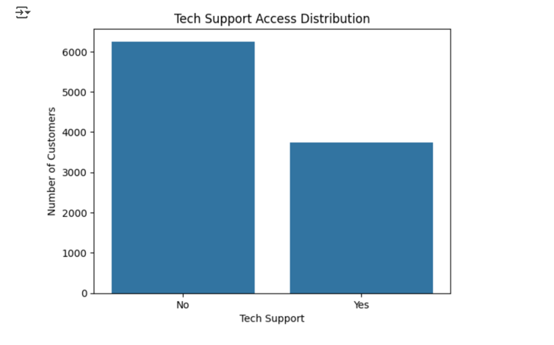
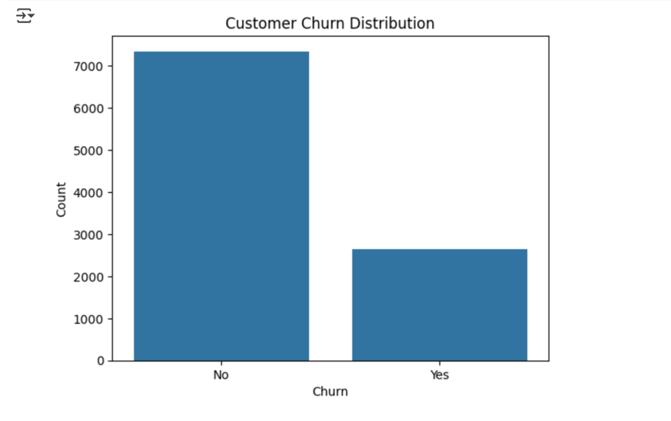
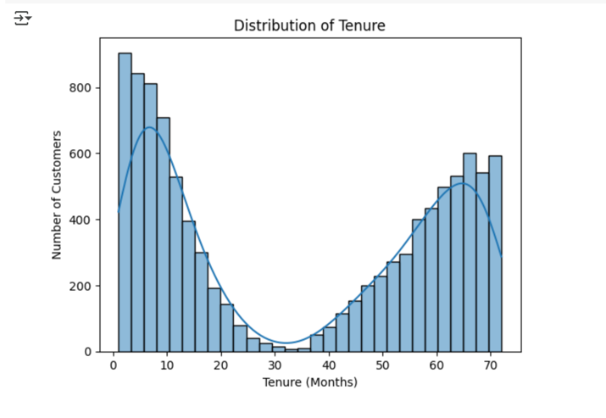

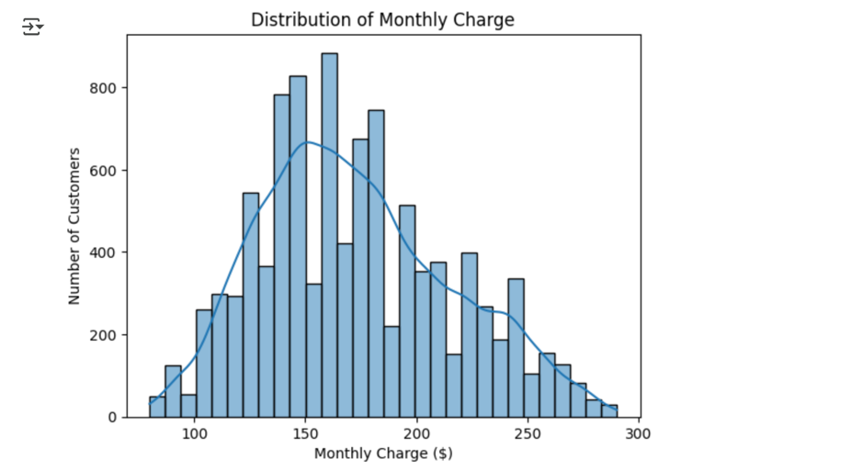
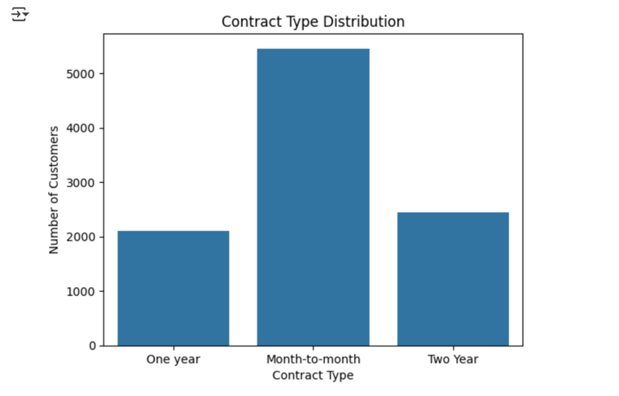

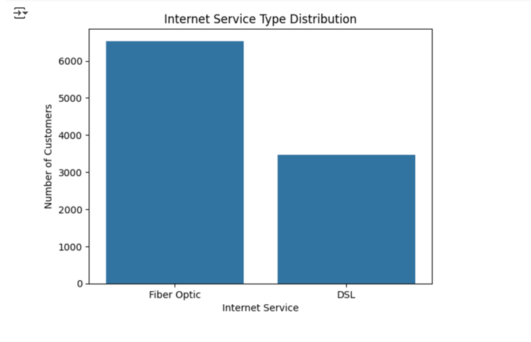
Bivariate Distributions
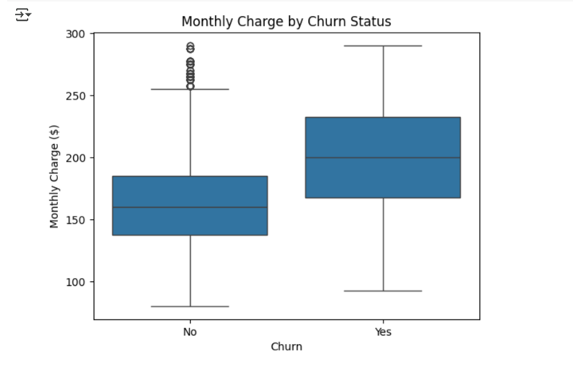
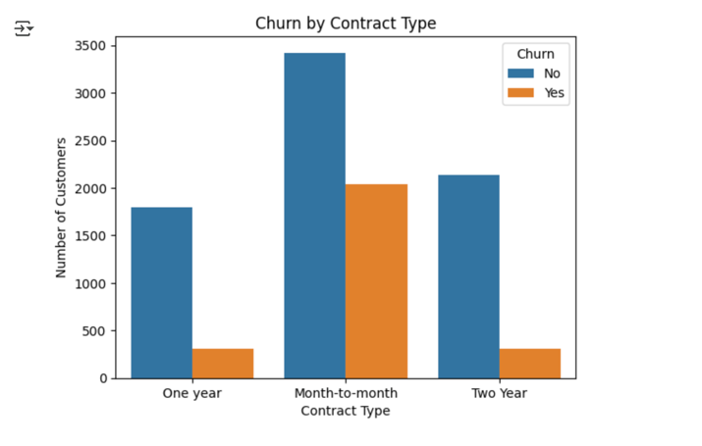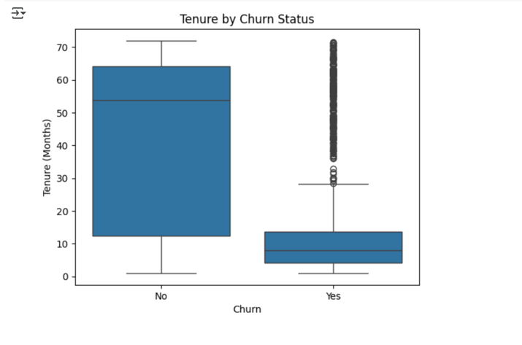
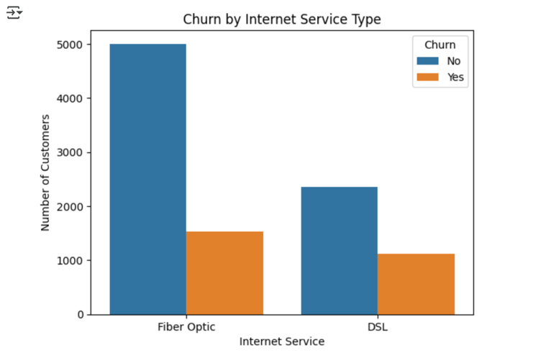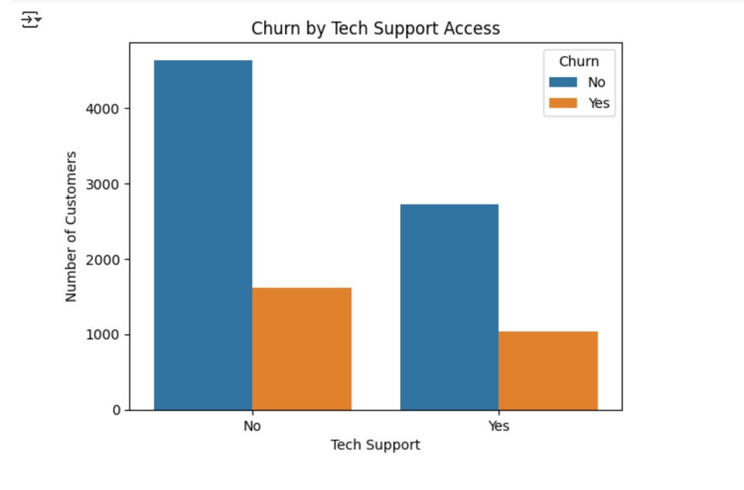
DATA TRANSFORMATION
The primary goal of data transformation in this project was to convert all variables into a format compatible with logistic regression while ensuring that the dataset was clean, consistent, and analytically sound. This process was intentionally preceded by a robust data cleaning phase, which addressed structural and statistical issues that could compromise model accuracy or interpretation.
The cleaning steps included removing non-informative columns such as 'Customer_id', checking for and imputing missing values (e.g., filling 'InternetService' using its mode), and converting string-based numerical columns like 'TotalCharges' into proper numeric format using pd.to_numeric(). Outliers were then addressed by computing Z-scores across all numeric columns and filtering out rows with absolute Z-scores greater than 3. This ensured that extreme values would not distort the model’s learning process.
After cleaning, the transformation process focused on preparing features for modeling. Categorical variables—including 'Contract', 'TechSupport', and 'InternetService'—were identified and converted into binary indicators using pd.get_dummies() with drop_first=True to avoid multicollinearity. The target variable 'Churn' was also transformed from string labels ('Yes' and 'No') into binary format (1 and 0, respectively) to meet the input requirements of logistic regression.
Throughout the process, careful attention was paid to the statistical assumptions of logistic regression. The structure of the dataset, along with its encoding and scaling, was deliberately shaped to produce a reliable and interpretable model. By embedding cleaning directly into the transformation pipeline, the resulting dataset was both statistically valid and optimized for predictive modeling.
Step 1: Load relevant libraries
import pandas as pd
import numpy as np
import seaborn as sns
import matplotlib.pyplot as plt
Step 2: Load dataset
import os
os.getcwd()
df = pd.read_csv('/Users/jensengbe/Desktop/School/Predictive Modeling/Linear Regression Modeling/Data Files/d9rkejv84kd9rk30fi2l/churn_clean.csv')
Step 3: Preview dataset
df.head(10)
Step 4: Print list of columns
print(df.columns.tolist())
Step 5: Drop columns not useful for modeling
df.drop(columns=['Customer_id'], inplace=True)
Step 6: Check for missing values
missing = df.isnull().sum()
print("Missing values per column:\n", missing[missing > 0])
Step 7: Handle missing values
df['InternetService'] = df['InternetService'].fillna(df['InternetService'].mode()[0])
Step 8: Identify categorical variables in the dataset
categorical_cols = df.select_dtypes(include=['object']).columns.tolist()
print("Categorical columns to encode:\n", categorical_cols)
Step 9: Select key numeric variables and prepare for multicollinearity check
selected_cols = ['Tenure', 'MonthlyCharge']
Step 10: Convert categorical variables into dummy variables
df_encoded = pd.get_dummies(df, columns=categorical_cols, drop_first=True)
Step 11: Add relevant service-related dummies if they exist
service_features = [
col for col in df_encoded.columns
if 'Contract' in col or 'TechSupport' in col or 'InternetService' in col
]
Step 12: Combine all relevant columns into final list
final_cols = selected_cols + service_features
Step 13: Visualize multicollinearity with a correlation matrix
# Create correlation matrix
plt.figure(figsize=(10, 8))
sns.heatmap(df_encoded[final_cols].corr(), cmap='coolwarm', annot=True, fmt=".2f", cbar=True)
plt.title("Correlation Matrix: Selected Features for Churn Analysis")
plt.show()
Step 14: Detect and remove outliers using Z-score
# Import relevant library
from scipy.stats import zscore

# Select only numeric columns
numeric_cols = df_encoded.select_dtypes(include=[np.number]).columns
z_scores = np.abs(zscore(df_encoded[numeric_cols]))
df_clean = df_encoded[(z_scores < 3).all(axis=1)]

# Print z-score
print(z_scores)
Step 15: Convert 'TotalCharges' column to numeric (with coercion for errors)
if 'TotalCharges' in df.columns:
df['TotalCharges'] = pd.to_numeric(df['TotalCharges'], errors='coerce')
Step 16: Convert 'Churn' column to binary (1 = Yes, 0 = No)
df['Churn'] = df['Churn'].map({'No': 0, 'Yes': 1})
Step 17: One-hot encode the full DataFrame again after all conversions
df_transformed = pd.get_dummies(df, columns=categorical_cols, drop_first=True)
Step 18: Confirm that all variables are now numeric
print(df_transformed.dtypes)
Step 19: Preview transformed dataset
df_transformed.head()
PREPARED DATASET
The prepared data set CSV file is attached to my submission under file name: C5.
INITIAL MODEL
The initial logistic regression model was developed using all independent variables identified in Part C2. The dataset underwent a thorough cleaning process, which included removing non-informative columns (e.g., Customer_id), handling missing values, converting string-based numeric columns like TotalCharges to proper numeric format, and filtering out outliers using Z-scores. These steps ensured data integrity and suitability for modeling.
After cleaning, categorical variables were one-hot encoded using pd.get_dummies() with drop_first=True to avoid multicollinearity. The target variable Churn was converted into a binary format (1 = Yes, 0 = No). The cleaned dataset was split into training and testing sets using an 80/20 split. Feature standardization was applied using StandardScaler to ensure numerical stability in the logistic regression process. The model was then fit using scikit-learn’s LogisticRegression with a maximum of 1000 iterations.
Evaluation of this initial model on the test set yielded an accuracy of 75%. The model performed well at identifying non-churners, with a recall of 97% for the "No Churn" class. However, its performance in detecting churners was weak, with a recall of only 16% and an F1-score of 0.25. These results highlight a class imbalance issue and the need for model refinement to improve sensitivity to churn behavior.
JUSTIFICATION OF MODEL REDUCTION
To improve interpretability and reduce redundancy, the initial model was refined through a statistically driven feature selection process. After one-hot encoding, the dataset had thousands of columns, many of which introduced multicollinearity and noise. To address this, statsmodels was used to evaluate the p-values of all predictors from the initial model. Variables with low p-values (p < 0.05) and strong business relevance were prioritized (Shreffler and Huecker).
While TechSupport_Yes was statistically significant (p < 0.001), it was excluded from the reduced model due to its relatively lower coefficient compared to other stronger predictors (Shreffler and Huecker). The following features were retained based on their statistical and practical impact:
- Tenure (longer tenure → lower churn risk)
- MonthlyCharge (higher charges → higher churn risk)
- Contract_One year and Contract_Two Year (longer contracts → reduced churn)
- InternetService_Fiber Optic (associated with churn risk, highlighting potential service-related concerns)
By focusing on these high-impact predictors, the reduced model maintains alignment with the research goal—identifying actionable drivers of churn—while enhancing model simplicity and avoiding overfitting.
REDUCED LOGISTIC REGRESSION MODEL
To create a more interpretable and statistically efficient model, a reduced logistic regression model was developed following the feature selection process outlined in Part D2. The reduced model retained only those predictors that demonstrated both statistical significance (p < 0.001) and practical relevance to the business problem of customer churn (Shreffler and Huecker).. These included Tenure, MonthlyCharge, InternetService_Fiber Optic, Contract_One year, and Contract_Two Year. Each of these variables had previously emerged as strong contributors in the initial model, either through high coefficient magnitudes or clear alignment with known customer behavior patterns.
The model was constructed using the statsmodels Logit function, which provided detailed output confirming the statistical significance of each retained variable. By excluding lower-impact predictors such as TechSupport_Yes, the model was simplified without sacrificing predictive power. The decision to omit this variable was based on its smaller coefficient and comparatively limited influence relative to contract types and service-related features. The reduced model, therefore, reflects a targeted approach that prioritizes business-critical insights while minimizing the risk of overfitting or introducing unnecessary complexity. Screenshots documenting both the initial and reduced model summaries are included to demonstrate the refinement and performance gains achieved through this reduction process.
Initial Logistic Regression Model:
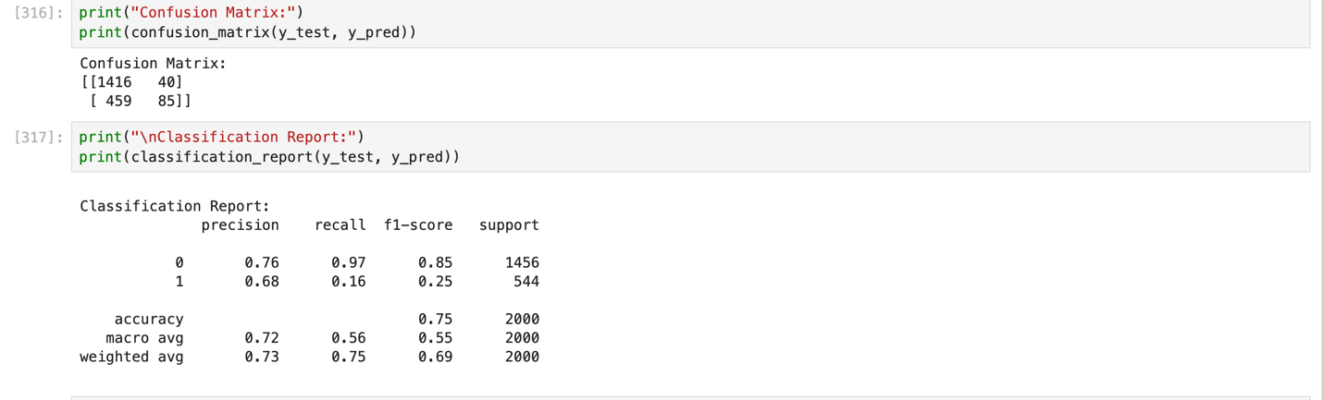
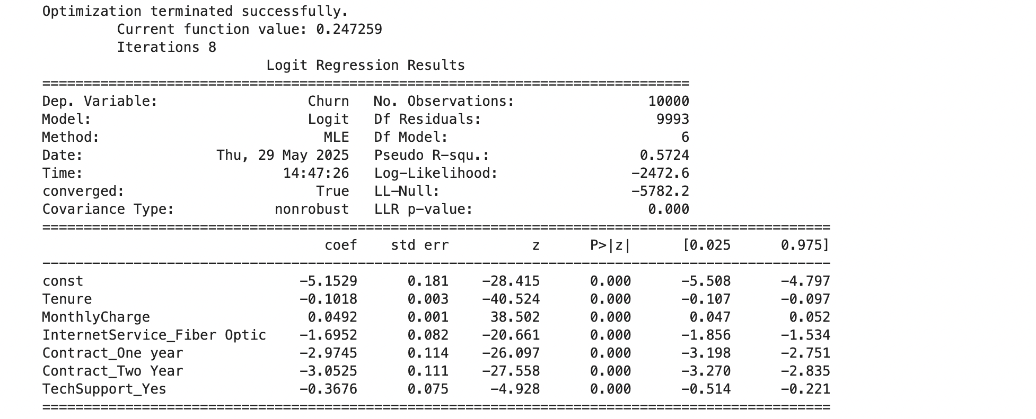
Reduced Logistic Regression Model:
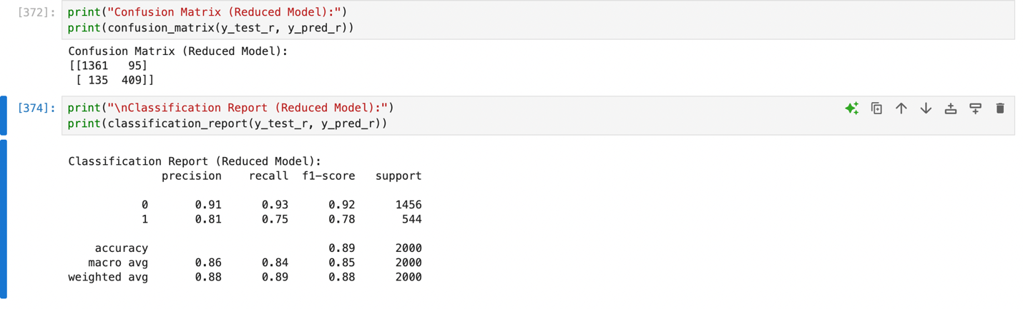
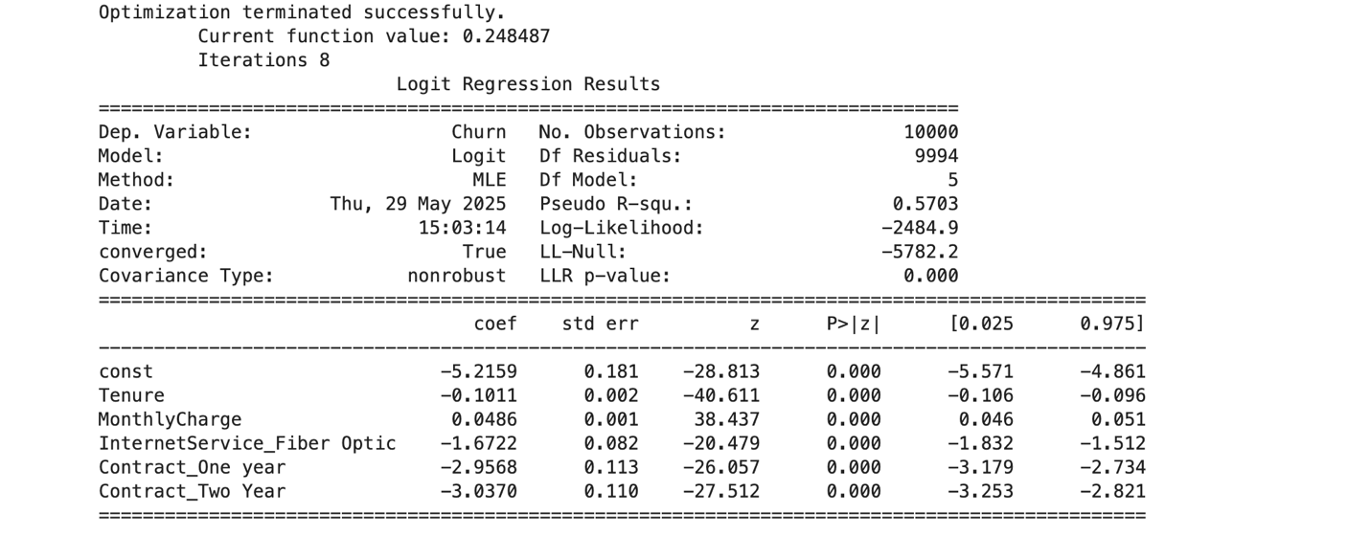

MODEL COMPARISON
To evaluate the effectiveness of the reduced logistic regression model, a comparative analysis was performed against the initial model using both structural and performance-based metrics. The initial model included all one-hot encoded variables, resulting in thousands of predictors that introduced complexity and potential multicollinearity. While it achieved an overall accuracy of 75% and performed well at identifying non-churners—with a recall of 97% for that class—it struggled significantly in identifying actual churners, achieving only a 16% recall and an F1-score of 0.25. This imbalance suggested that the model was biased toward the majority class and needed refinement.
In contrast, the reduced model significantly improved on both simplicity and performance. By narrowing the feature set to only statistically significant and business-relevant predictors, the model achieved an overall accuracy of 89%. More notably, recall for the churn class rose sharply to 75%, and the F1-score improved to 0.78, indicating a much better balance between precision and recall. These improvements demonstrate that the reduced model not only maintains predictive accuracy but also strengthens the model’s ability to detect at-risk customers—an essential outcome given the business goal of reducing churn. The model’s streamlined structure, improved class balance, and clarity of interpretation make it a more effective and deployable tool for real-world churn prediction strategies.
OUTPUTS AND CALCULATIONS
The reduced logistic regression model was evaluated using performance metrics applied to the test dataset. These metrics included a confusion matrix, classification report, and overall accuracy score. The confusion matrix revealed that the model correctly predicted 1,361 customers who did not churn (true negatives) and 409 customers who did churn (true positives). It misclassified 135 churners as non-churners (false negatives) and 95 non-churners as churners (false positives). This result represents a marked improvement over the initial model, especially in its ability to correctly identify churners—a key goal in churn prediction analysis.
The classification report reinforced these findings, showing a recall of 75% and precision of 81% for the churn class, resulting in an F1-score of 0.78. The model achieved an overall accuracy of 89%, significantly higher than the 75% accuracy recorded by the initial model. These improvements reflect the reduced model’s stronger class balance and enhanced ability to detect true positives, which are essential for taking timely and effective customer retention actions. Despite having fewer features, the reduced model maintained statistical rigor and delivered meaningful practical insights, confirming its suitability for real-world implementation in identifying customers at risk of churning.
CODE
The Python file used to conduct the logistic regression analysis is provided and labeled as “E3”. This script includes all relevant code used to preprocess the data, build the initial and reduced models, calculate evaluation metrics, and generate the outputs referenced throughout the report. The file is organized to reflect the sequence of analysis, ensuring that each step aligns with the explanations and justifications provided in Parts C through E2.
RESULTS
The reduced logistic regression model can be expressed by the following equation:
log(p / (1 − p)) = β₀ + β₁ × Tenure + β₂ × MonthlyCharge + β₃ × InternetService_Fiber Optic + β₄ × Contract_One year + β₅ × Contract_Two Year (Shreffler and Huecker).
In this equation, p represents the probability of customer churn. The intercept (β₀) denotes the baseline log-odds of churn when all predictors are set to zero, and each coefficient (βᵢ) reflects the change in log-odds of churn associated with a one-unit increase in that predictor, holding all else constant.
Each variable in the reduced model was found to be both statistically significant (p < 0.001) and practically relevant (Shreffler and Huecker). Tenure had a negative coefficient, indicating that the longer a customer remains subscribed, the less likely they are to churn—a finding consistent with customer loyalty patterns. MonthlyCharge displayed a positive coefficient, suggesting that customers with higher monthly costs are more likely to leave, potentially due to cost sensitivity or unmet service expectations.
The categorical variables also yielded important insights. Contract_One year and Contract_Two Year had large, negative coefficients compared to the reference group (month-to-month contracts), demonstrating that customers with longer-term agreements are substantially less likely to churn. This reinforces the idea that contract duration contributes meaningfully to retention. Similarly, InternetService_Fiber Optic had a strong negative coefficient, suggesting that customers with fiber service are more satisfied and less inclined to leave.
From a statistical perspective, all predictors retained in the reduced model had p-values well below the 0.05 threshold, indicating robust significance (Shreffler and Huecker). The pseudo R-squared value of 0.5703 demonstrates good model fit, and the improved classification performance—particularly for the churn class—validates the predictive strength of the reduced feature set.
Practically, the reduced model offers actionable insight while maintaining interpretability. Its variables directly reflect customer behaviors and service attributes, making it a valuable tool for guiding retention strategies.
That said, limitations must be acknowledged. The model is based on observational data, which means it captures associations rather than causality. Additionally, external influences—such as competitor promotions, economic shifts, or changes in service delivery—are not represented in the dataset. Moreover, while logistic regression assumes a linear relationship between the log-odds of the outcome and the predictors, real-world behaviors may be more complex.
Overall, the reduced logistic regression model delivers strong statistical validity and meaningful business relevance. It highlights clear drivers of churn and empowers decision-makers with evidence-based insights to support strategic customer retention initiatives.
RECOMMENDATIONS
Based on the insights obtained from the reduced logistic regression model, several targeted recommendations can be made to help the telecommunications company mitigate churn and strengthen customer retention. The model identified four key predictors of churn: tenure, monthly charges, internet service type, and contract duration. Each of these variables presents opportunities for strategic action that directly supports the research goal of reducing customer attrition.
First, customers on one- and two-year contracts were significantly less likely to churn compared to those on month-to-month plans. To leverage this finding, the company should consider promoting longer-term contracts by offering incentives such as introductory discounts, added service features, or bundled plans. These promotions can help lock in customer loyalty while improving revenue predictability.
Second, tenure was negatively associated with churn, indicating that newer customers are at higher risk of leaving. This suggests that the early months of the customer lifecycle are a critical period for engagement. The company should implement onboarding strategies that include personalized welcome campaigns, helpful tutorials, and proactive check-ins to reinforce value and establish a positive customer experience early on.
Third, monthly charges had a positive correlation with churn, suggesting that customers who pay more are more prone to dissatisfaction. To address this, the company should periodically review pricing structures and customer plan usage. Offering flexible plan adjustments, value-driven upsell recommendations, or loyalty discounts could help reduce perceived cost burdens and enhance satisfaction.
Finally, the model showed that customers subscribed to fiber optic internet were less likely to churn—possibly due to better service quality or performance. The company should capitalize on this by expanding access to fiber service, highlighting its advantages in marketing communications, and ensuring that existing fiber customers receive consistent, high-quality support to preserve satisfaction.
Collectively, these recommendations are informed directly by the data and offer a roadmap for strategic retention efforts. By aligning initiatives with customer behaviors and service-related variables identified in the model, the company can take measurable steps toward reducing churn and building long-term customer value.

SOURCES
Altman, Douglas G., and J. Martin Bland. "Standard Deviations and Standard Errors." BMJ, vol. 331, no. 7521, 2005, p. 903. British Medical Journal Publishing Group, https://www.ncbi.nlm.nih.gov/pmc/articles/PMC1198040/.
Joshi, Ankush, and Haripriya Tiwari. "An Overview of Python Libraries for Data Science." Journal of Engineering Technology and Applied Physics, vol. 5, no. 2, Sept. 2023, pp. 85–90. MMU Press, https://www.researchgate.net/publication/373974658_An_Overview_of_Python_Libraries_for_Data_Science.
"Logistic Regression in Clinical Studies." International Journal of Radiation Oncology, Biology, Physics, vol. 111, no. 1, 2021, pp. 68–80. Elsevier, https://www.redjournal.org/article/S0360-3016(21)02646-8/fulltext.
Shreffler, John, and Michael R. Huecker. Hypothesis Testing, P Values, Confidence Intervals, and Significance. StatPearls Publishing, Jan. 2025. StatPearls, https://www.ncbi.nlm.nih.gov/books/NBK557421/.

